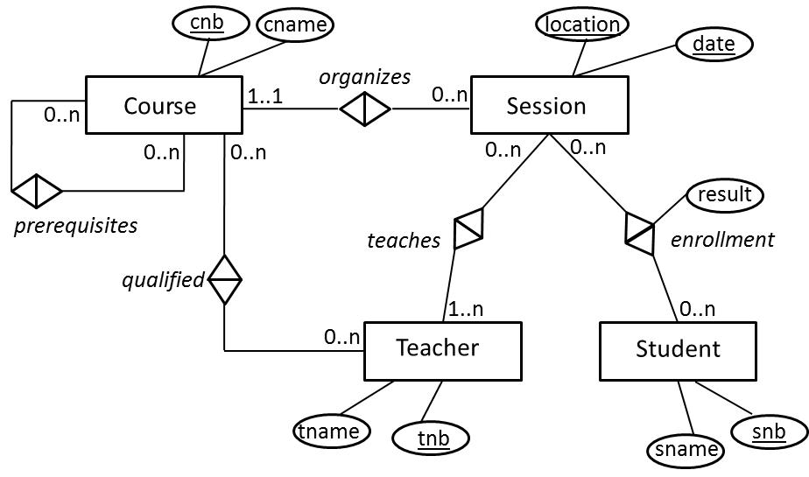

Let’s consider mapping the relationship type Teaches between Session and Teacher as follows:

Session(location,date)

Teacher(tnb, tname)

Teaches(*location, date, tnb*)

Assume now we have the following tuples:

Session(Leuven, 29/10/2020)

Session(Bruges, 30/10/2020)

Session(New York, 1/11/2020)

Session(San Francisco, 2/11/2020)

Teacher(1, Bart)

Teacher(2; Wilfried)

Teacher(3, Claudia)

Teacher(4, Amber)

Teaches(Leuven, 29/10/2020, 1)

Teaches(Leuven, 29/10/2020, 2)

Teaches(Bruges, 30/10/2020, 3)

Teaches(Bruges, 30/10/2020, 1)

**Has every session at least 1 teacher (we are checking the minimum cardinality of 1)?**

No, because the sessions in New York and San Francisco have no teacher so the minimum cardinality of 1 is not enforced in the relational model.

**Can a session have multiple teachers (we are checking the maximum cardinality of n)?**

Yes, the sessions in Leuven and Bruges have both 2 teachers so the maximum cardinality is OK.

**Are there teachers who give 0 sessions? (we are now checking the minimum cardinality of 0).**

Yes, Amber is not teaching any sessions.

**Are there teachers who give multiple sessions? (we are now checking the maximum cardinality of n).**

Yes, because Bart teaches sessions in Bruges and Leuven.